ONLINE SHOPPING SYSTEM
A DBMS Capstone Project Report submitted in partial fulfillment of the requirements for the award of the degree of
BACHELOR OF TECHNOLOGY
in
ARTIFICIAL INTELLIGENCE AND MACHINE LEARNING

Submitted By
PANGA.NIKHIL SAI KUMAR REDDY – 25B11AI895
PITTA. SRILEKHA THARA – 25B11AI966
ANUSURI. SHANMUKA PRIYA LAKSHMI – 25B11AI056
PEDIREDDY. SURYA PRAKASH – 25B11AI929

Under the esteemed guidance of
Mr. T.Srinivasulu M.Tech, (Ph.D.)
Assistant Professor



DEPARTMENT OF ARTIFICIAL INTELLIGENCE AND MACHINE LEARNING
ADITYA UNIVERSITY
(Formerly Aditya Engineering College (A))
Aditya Nagar, ADB Road, Surampalem, Andhra Pradesh, India
2026 – 2027

Aditya Nagar, ADB Road, Surampalem, Andhra Pradesh, India
DEPARTMENT OF ARTIFICIAL INTELLIGENCE AND MACHINE LEARNING
CERTIFICATE
This is to certify that the DBMS Capstone Project report entitled “ONLINE SHOPPING SYSTEM” is being submitted by P.Nikhil sai kumar reddy (25B11AI895), P.Srilekha thara (25B11AI966), A.Shanmukha Priya Lakshmi (25B11AI056) and P.Surya prakash(25B11AI929) in partial fulfillment of the requirements for the award of the B.Tech. degree in Artificial Intelligence and Machine Learning. The work documented in this report was carried out as part of the Capstone Project for the course Database Management Systems (2501IT05) during the academic year 2026–2027, and records the database design, implementation, and documentation undertaken by the team.

Project Guide Head of the Department
Mr. T. Srinivasulu, M. Tech, (Ph.D.) Dr. K. Naga Bhargavi, M. Tech, Ph.D. Associate professor Associate Professor & HOD

External Examiner

DECLARATION
We hereby declare that the DBMS Capstone Project entitled “ONLINE SHOPPING SYSTEM” is a genuine work carried out by us. The database design, SQL implementation, queries and documentation presented in this report are our own work, completed under the guidance of MR T.Srinivasulu sir , Department of Artificial intelligence & machine learning , Aditya University, Surampalem. We further declare that this work has not been submitted, in full or in part, for the award of any degree of this or any other educational institution.

Project Associates
P.Nikhil sai kumar reddy (25B11AI895)
P.Srilekha thara (25B11AI966)
A.Shanmukha (25B11AI056)
P.Surya Prakash (25B11AI929)

Date: ____________
Place: Surampalem

ACKNOWLEDGEMENT
It is with immense pleasure that we express our indebted gratitude to our project guide MR.T.Srinivasulu sir, Department of Artificial Intelligence&Machine Learning, who guided us throughout the capstone project. We are thankful for the constant encouragement and valuable suggestions received at every review stage.
We are grateful to ____________________, Head of the Department, for inspiring us and for arranging the facilities and resources needed for this project.
We extend our sincere thanks to the Management, Dr. M. Sreenivasa Reddy, Deputy Pro-Chancellor, Dr. M. B. Srinivas, Vice-Chancellor, and Dr. A. Ramesh, Pro Vice-Chancellor (Engineering & Sciences), for providing an excellent academic environment.
Not to forget, we thank the Teaching and Non-Teaching Staff, our parents and our friends, who have directly or indirectly supported us in completing this project on time.

Project Associates
P.Nikhil sai kumar reddy (25B11AI895)
P.Srilekha thara (25B11AI966)
A.Shanmukha (25B11AI056)
P.Surya Prakash (25B11AI929)

ABSTRACT.
The Online Shopping System is a database-based e-commerce application that helps customers buy products online easily and efficiently. Customers can browse products, add items to a cart, place orders, make payments, track deliveries, and give reviews. The main problem with traditional manual or spreadsheet-based systems is that they create duplicate records, are difficult to manage, and become slow as the number of customers and products increases.
The purpose of this database is to store and manage all shopping-related information in one organized system. It includes details about customers, products, categories, orders, payments, shipping, and reviews. The database ensures that data is accurate, secure, and easy to access.
The major functionalities of the system include product management, customer registration, shopping cart management, order processing, payment handling, delivery tracking, and review management. The database is designed using a normalized relational structure to reduce redundancy and improve performance.
The key outcome of this project is a reliable, scalable, and efficient database design that supports smooth online shopping operations, maintains data consistency, and provides a strong foundation for future application development.
The database is designed using normalization techniques up to Third Normal Form (3NF) to reduce data redundancy and maintain consistency. Primary keys, foreign keys, unique constraints, and validation rules are implemented to ensure data integrity and accuracy. SQL operations such as data insertion, retrieval, updating, deletion, joins, aggregate functions, views, and subqueries are used to support efficient database management and reporting.

The system provides a centralized repository for managing online shopping transactions, enabling quick access to information and effective handling of customer orders. By maintaining accurate and structured data, the Online Shopping System improves operational efficiency, minimizes errors, and supports reliable decision-making. This project demonstrates the practical application of database management concepts in developing a scalable and well-structured e-commerce database solution.

INDEX
Chapter | Title | Page No.
 | Certificate | 1
 | Declaration | 2
 | Acknowledgement | 3
 | Abstract | 4
 | List of Figures | 5
 | List of Tables | 6
1 | Introduction | 8
 | 1.1 Introduction to the Domain | 8
 | 1.2 Problem Statement | 8
 | 1.3 Motivation and Need for a Database | 9
 | 1.4 Objectives of the Project | 9
 | 1.5 Scope of the Project | 9
 | 1.6 Organization of the Report | 10
2 | System Study and Tools | 11
 | 2.1 Existing System and Its Limitations | 11
 | 2.2 Proposed Database System | 11
 | 2.3 Tools and Technologies Used | 11
 | 2.4 Software and Hardware Requirements | 12
3 | Database Design (Review – I) | 13
 | 3.1 Identified Entities | 13
 | 3.2 Entity Attributes and Attribute Types | 13
 | 3.3 ER Diagram | 15
 | 3.4 Relationships and Cardinality | 15
 | 3.5 Relational Database Schema | 16
 | 3.6 Primary Keys and Foreign Keys | 19
 | 3.7 Normalization up to 3NF | 20
4 | Database Implementation (Review – II) | 21
 | 4.1 Database and Table Creation – DDL | 21
 | 4.2 Sample Data Insertion – DML | 24
 | 4.3 Constraints and Data Integrity | 29
 | 4.4 Data Validation Rules | 30
5 | SQL Operations and Queries | 32
 | 5.1 DQL – Basic Retrieval Queries | 32
 | 5.2 Join Operations | 33
 | 5.3 Aggregate Functions, GROUP BY and HAVING | 35
 | 5.4 Nested and Correlated Subqueries | 36
 | 5.5 Views and Relational Set Operations | 38
 | 5.6 DCL and TCL Operations | 40
6 | Modules and Functionalities | 41
7 | Results – Sample Outputs and Screenshots | 42
8 | Testing and Data Validation | 45
9 | GitHub Repository and Team Contribution | 46
10 | Conclusion and Future Enhancements | 48
 | References | 49
 | Appendix A – Complete SQL Script

LIST OF FIGURES
Figure No. | Title of the Figure | Page No.
Fig. 3.1 | ER Diagram of the online shopping System | 15
Fig. 3.2 | Relational Schema Diagram | 19
Fig. 4.1 | Successful Creation of Tables | 24
Fig. 4.2 | Sample Data Inserted into the Tables | 26
Fig. 4.3 | Referential Integrity Enforced by the Database | 30
Fig. 7.1 | Shows customer order history output | 42
Fig. 7.2 | Product inventory output | 43

LIST OF TABLES
Table No. | Title of the Table | Page No.
Table 2.1 | Tools and Technologies Used | 11
Table 2.2 | Software and Hardware Requirements | 12
Table 3.1 | Entities Identified for the Selected Domain | 13
Table 3.2 | Attributes of Each Entity | 13
Table 3.3 | Relationships and Cardinality | 15
Table 3.4 | Relational Database Schema | 16
Table 3.5 | Primary Key and Foreign Key Definitions | 19
Table 3.6 | Normalization Steps | 20
Table 4.1 | Sample Data Summary | 24
Table 4.2 | Constraints and Data Integrity Rules | 29
Table 6.1 | Modules and Their Functionalities | 41
Table 8.1 | Test Cases and Results | 45
Table 9.1 | Team Responsibilities | 46
Table 9.2 | Review-wise Progress Record | 46

CHAPTER 1: INTRODUCTION

1.1 Introduction to the Domain
The Online Shopping System is an e-commerce application that allows customers to purchase products through the internet. It provides a convenient platform where users can browse products, add items to a shopping cart, place orders, make online payments, track deliveries, and submit reviews. The system also helps administrators manage products, inventory, orders, payments, and customer information efficiently. As online shopping continues to grow, businesses need a reliable way to store and manage large amounts of data generated by customers and transactions.
A database is required because the system handles thousands of products, customers, orders, and payments that must be stored accurately without duplication. It ensures data integrity, security, and consistency while supporting multiple users at the same time. The database also enables fast retrieval of information, efficient order processing, inventory management, and report generation. Unlike manual records or spreadsheets, a database provides structured storage, transaction management, and scalability, making the online shopping system more reliable and efficient.

1.2 Problem Statement
Existing problem:
The Online Shopping System aims to overcome the limitations of traditional file-based retail management systems, such as data redundancy, integrity issues, poor scalability, weak security, and inefficient data retrieval. The proposed solution is a normalized relational database that manages customers, products, orders, payments, shipping, and reviews through interconnected tables with integrity constraints. This database ensures accurate, secure, scalable, and efficient management of e-commerce operations while supporting reliable transaction processing and reporting.
Limitations:
Traditional retail businesses and small online sellers often manage customer, product, order, and payment information using spreadsheets or manual record-keeping methods. As the volume of transactions increases, these approaches become inefficient and difficult to maintain. Customer details, product information, and order records may be duplicated across multiple files, leading to data redundancy and inconsistency. Retrieving information such as order history, product availability, and sales reports becomes time-consuming and prone to errors.

In addition, manual systems lack proper integrity checks and security mechanisms. Orders may reference unavailable products, inventory levels may not be updated accurately, and unauthorized access to sensitive customer or payment information may occur. The absence of a centralized database also makes it difficult to maintain data consistency, support concurrent users, and generate meaningful business reports.

To address these challenges, this project proposes an Online Shopping System database that stores and manages customers, products, categories, orders, payments, shipping details, and reviews in a structured relational database. The system enforces data integrity through primary keys, foreign keys, and validation constraints, reduces redundancy through normalization, and enables efficient data retrieval using SQL queries. This provides a reliable, secure, and scalable solution for managing e-commerce operations effectively.

1.3 Motivation and Need for a Database
The rapid growth of e-commerce platforms has increased the volume of data generated through customer registrations, product listings, orders, payments, shipping details, and product reviews. Managing such large amounts of information using manual records, spreadsheets, or separate files often leads to data redundancy, inconsistency, and difficulties in data retrieval and maintenance.

An Online Shopping System requires a Database Management System (DBMS) to store and manage data in a structured and organized manner. A DBMS ensures data integrity through primary keys, foreign keys, and validation constraints, thereby preventing duplicate and invalid records. It also supports efficient retrieval of information through SQL queries, enabling quick access to customer details, product inventories, order histories, and sales reports.

Furthermore, a database provides multi-user access, transaction management, security, and scalability, which are essential for modern e-commerce applications. As the number of customers and products increases, the database can efficiently handle large volumes of data while maintaining consistency and performance. Therefore, implementing a relational database is essential for ensuring reliable, secure, and efficient management of the Online Shopping System.

1.4 Objectives of the Project
- To design a normalized relational database for the online shopping system with at least six entities, and to represent the design as an ER diagram showing all attributes ,relationships and cardinalities
- To implement the database with appropriate primary keys, foreign keys and integrity constraints.
- To perform SQL operations including DDL, DML, DQL, joins, aggregate functions, subqueries, views, and set operations for effective data management and retrieval.
- To enforce data integrity and validation through constraints such as NOT NULL, UNIQUE, CHECK, DEFAULT, and referential integrity rules.
- To test the database using transaction control operations, security commands, and sample business queries to ensure correctness, consistency, and reliability.

1.5 Scope of the Project
The Online Shopping System database covers the storage and management of customer information, product categories, products, shopping carts, orders, order items, payments, shipping details, and customer reviews. It supports essential e-commerce operations such as customer registration, product browsing, cart management, order placement, payment recording, shipment tracking, and review management. The database also provides facilities for maintaining data integrity, enforcing relationships between entities, and generating reports through SQL queries. The design is normalized up to Third Normal Form (3NF) to minimize redundancy and ensure consistency of data.

The database does not cover the development of a complete web or mobile application interface, real-time payment gateway integration, live inventory synchronization with external vendors, product recommendation systems, online customer support, advanced security features such as encryption and multi-factor authentication, cloud deployment, backup and recovery mechanisms, or business analytics dashboards. These features are beyond the scope of the current project and may be considered for future enhancements.

1.6 Organization of the Report
This report is organized into ten chapters. Chapter 2 presents the system study and the tools used. Chapter 3 covers the complete database design including the ER diagram, relational schema and normalization. Chapter 4 describes the database implementation with DDL and sample data. Chapter 5 presents the SQL operations and queries executed. Chapter 6 explains the modules and functionalities. Chapter 7 presents the results with sample outputs. Chapter 8 covers testing and data validation. Chapter 9 details the GitHub repository and the contribution of each team member. Chapter 10 concludes the report and outlines future enhancements.

CHAPTER 2: SYSTEM STUDY AND TOOLS

2.1 Existing System and Its Limitations
The existing system for managing online shopping activities often relies on manual record keeping, spreadsheets, or independent files to store customer, product, and order information. As the number of customers and transactions increases, maintaining data becomes difficult and time-consuming. Data redundancy, inconsistency, and retrieval delays are common problems. Additionally, manual systems do not provide proper data integrity, security, or support for multiple users accessing data simultaneously.
Limitations of the Existing System
- Data redundancy and duplication.
- Difficulty in maintaining large volumes of data.
- Slow retrieval of customer and order information.
- Poor data integrity and consistency.
- Limited security and access control.
- Difficulty in generating reports and summaries.

2.2 Proposed Database System
The proposed Online Shopping System uses a relational database to store and manage customer, product, order, payment, shipping, and review information in a structured manner. The system minimizes redundancy through normalization and maintains data integrity using primary keys, foreign keys, and validation constraints. It enables efficient storage, retrieval, and management of e-commerce data through SQL operations.
Advantages of the Proposed System
- Centralized and organized data storage.
- Reduced data redundancy and inconsistency.
- Faster data retrieval using SQL queries.
- Improved security and integrity through constraints.
- Support for multiple related entities and transactions.
- Easy generation of reports and summaries.

2.3 Tools and Technologies Used
Table 2.1: Tools and Technologies Used
Category | Tool / Technology Used | Version / Remarks
Database Server | MySQL | MySQL 8.0
Query / Administration Tool | MySQL Workbench | Used for creating tables and executing SQL queries
ER Diagram Tool | draw.io (diagrams.net) | Used for ER Diagram and Relational Schema Design
Version Control | GitHub | Repository for project files and collaboration
Documentation | Microsoft Word | Used for report preparation and documentation

2.4 Software and Hardware Requirements
Table 2.2: Software and Hardware Requirements
Requirement Type | Specification
Operating System | Windows 10 / Windows 11
Database Server | MySQL 8.0
Query / Administration Tool | MySQL Workbench
ER Diagram Tool | draw.io (diagrams.net)
Version Control | GitHub
Documentation Tool | Microsoft Word
Processor | Intel Core i3 / AMD Ryzen 3 or higher
RAM | Minimum 4 GB (Recommended 8 GB)
Storage | Minimum 20 GB Free Disk Space
Internet Connection | Required for GitHub and online resources
Display | 1366 × 768 Resolution or higher

CHAPTER 3: DATABASE DESIGN

3.1 Identified Entities
Six core entities were identified from the study of the domain, together with two supporting tables introduced during normalization to hold multi-valued attributes.
Table 3.1: Entities Identified for the Selected Domain
S.No | Entity Name | Description
1. | Customer | Registered buyer with login, contact and address details
2. | Product | Item on sale with price, stock and description
3. | Category | Group that classifies products (Electronics, Fashion…)
4. | Order | A purchase placed by a customer on a given date.
5. | Payment | Transaction record for an order: mode, amount, status.
6. | Shipping | Delivery details, courier and tracking for an order.

3.2 Entity Attributes and Attribute Types
The attributes of each entity are listed below with the data type, the key role and the attribute classification. The classification follows the ER model: an attribute is Simple if it cannot be divided further, Composite if it is made up of smaller attributes, Multi-valued if one entity instance may hold several values, and Derived if its value is computed from other stored attributes.

Table 3.2: Attributes of Each Entity
Entity | Attribute | Data Type | Key (PK / FK / —) | Attribute Type
Customer | customer_id | INT | PK | Simple
Customer | name | VARCHAR(100) | __ | Composite
Customer | email | VARCHAR(100) | — | Simple
Customer | phone | VARCHAR(15) | — | Multi-valued
Customer | password | VARCHAR(255) | — | Simple
Customer | address | VARCHAR(255) | — | Composite
Customer | city | VARCHAR(50) | — | Simple
Customer | pincode | VARCHAR(10) | — | Simple
Product | product_id | INT | PK | Simple
Product | name | VARCHAR(100) | — | Simple
Product | description | TEXT | — | Simple
Product | price | DECIMAL(10,2) | — | Simple
Product | stock_qty | INT | — | Simple
Product | category_id | INT | FK | Simple
Category | category_id | INT | PK | Simple
Category | category_name | VARCHAR(100) | — | Simple
Category | description | TEXT |  | Simple
Order | order_id | INT | PK | Simple
Order | order_date | DATE | — | Simple
Order | total_amount | DECIMAL(10,2) | — | Derived
Order | status | VARCHAR(20) | — | Simple
Order | customer_id | INT | FK | Simple
Order_Item | order_id | INT | PK, FK | Simple
Order_Item | product_id | INT | PK, FK | Simple
Order_Item | quantity | INT | — | Simple
Order_Item | unit_price | DECIMAL(10,2) | — | Simple
Payment | payment_id | INT | PK | Simple
Payment | order_id | INT | FK | Simple
Payment | payment_mode | VARCHAR(30) | — | Simple
Payment | amount | DECIMAL(10,2) | — | Simple
Payment | pay_date | DATE | — | Simple
Payment | status | VARCHAR(20) | — | Simple
Shipping | shipping_id | INT | PK | Simple
Shipping | order_id | INT | FK | Simple
Shipping | address | VARCHAR(255) | — | Composite
Shipping | courier | VARCHAR(100) | — | Simple
Shipping | tracking_no | VARCHAR(50) | — | Simple
Shipping | delivery_date | DATE | — | Simple
Review | review_id | INT | PK | Simple
Review | customer_id | INT | FK | Simple
Review | product_id | INT | FK | Simple
Review | rating | INT | — | Simple
Review | comment | TEXT | — | Simple
Review | review_date | DATE | — | Simple

3.3 ER Diagram
The ER diagram below shows the six core entities as rectangles, their attributes as ellipses with primary key attributes underlined, and the relationships as named diamonds with the cardinality marked on every line.
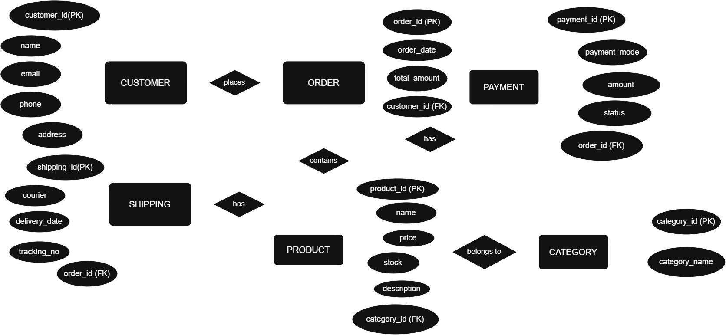

Fig. 3.1: ER Diagram of the Online Shopping System

3.4 Relationships and Cardinality
Table 3.3: Relationships and Cardinality
Entity 1 | Relationship | Entity 2 | Cardinality (1:1 / 1:N / M:N) | Participation
CATEGORY | Page | 16Contains | PRODUCT | 1 : M | Partial – Total
CUSTOMER | Places | ORDER | 1 : M | Partial – Total
ORDER | Contains | PRODUCT | M : N | Total – Partial
ORDER | Paid By | PAYMENT | 1 : 1 | Total – Total
ORDER | Shipped Via | SHIPPING | 1 : 1 | Total – Total
CUSTOMER | Reviews | PRODUCT | M : N | Partial – Partial
CUSTOMER | Owns | CART | 1 : 1 | Partial – Total
CART | Holds | PRODUCT | M : N | Partial – Partial

3.5 Relational Database Schema
The ER design was converted into the following relational schema. Each entity became a table, each multi-valued attribute became a separate table, and each relationship was implemented by placing the foreign key on the many side.
Table 3.4: Relational Database Schema
Table Name | Column Name | Data Type | Key (PK / FK / —) | Constraints
Customer | customer_id | INT | PK | NOT NULL
Customer | name | VARCHAR(100) | __ | UNIQUE, NOT NULL
Customer | email | VARCHAR(100) | — | NOT NULL
Customer | phone | VARCHAR(15) | — | NOT NULL
Customer | password | VARCHAR(255) | — | NOT NULL
Customer | address | VARCHAR(255) | — | NOT NULL
Customer | city | VARCHAR(50) | — | NOT NULL
Customer | pincode | VARCHAR(10) | — | NOT NULL
Product | product_id | INT | PK | NOT NULL, AUTO_INCREMENT
Product | name | VARCHAR(100) | — | NOT NULL
Product | description | TEXT | — | NULL
Product | price | DECIMAL(10,2) | — | NOT NULL, CHECK(price > 0)
Product | stock_qty | INT | — | DEFAULT 0
Product | category_id | INT | FK | REFERENCES CATEGORY(category_id)
Category | category_id | INT | PK | NOT NULL, AUTO_INCREMENT
Category | category_name | VARCHAR(100) | — | NOT NULL
Category | description | TEXT |  | NULL
Order | order_id | INT | PK | NOT NULL, AUTO_INCREMENT
Order | order_date | DATE | — | NOT NULL
Order | total_amount | DECIMAL(10,2) | — | NOT NULL
Order | status | VARCHAR(20) | — | DEFAULT 'Pending'
Order | customer_id | INT | FK | REFERENCES CUSTOMER(customer_id)
Order_Item | order_id | INT | PK, FK | REFERENCES ORDERS(order_id)
Order_Item | product_id | INT | PK, FK | REFERENCES PRODUCT(product_id)
Order_Item | quantity | INT | — | NOT NULL, CHECK(quantity > 0)
Order_Item | unit_price | DECIMAL(10,2) | — | NOT NULL
Payment | payment_id | INT | PK | NOT NULL, AUTO_INCREMENT
Payment | order_id | INT | FK | REFERENCES ORDERS(order_id)
Payment | payment_mode | VARCHAR(30) | — | NOT NULL
Payment | amount | DECIMAL(10,2) | — | NOT NULL
Payment | pay_date | DATE | — | NOT NULL
Payment | status | VARCHAR(20) | — | DEFAULT 'Success'
Shipping | shipping_id | INT | PK | NOT NULL, AUTO_INCREMENT
Shipping | order_id | INT | FK | REFERENCES ORDERS(order_id)
Shipping | address | VARCHAR(255) | — | NOT NULL
Shipping | courier | VARCHAR(100) | — | NOT NULL
Shipping | tracking_no | VARCHAR(50) | — | UNIQUE
Shipping | delivery_date | DATE | — | NULL
Review | review_id | INT | PK | NOT NULL, AUTO_INCREMENT
Review | customer_id | INT | FK | REFERENCES CUSTOMER(customer_id)
Review | product_id | INT | FK | REFERENCES PRODUCT(product_id)
Review | rating | INT | — | CHECK(rating BETWEEN 1 AND 5)
Review | comment | TEXT | — | NULL
Review | review_date | DATE | — | NOT NULL
CART | cart_id | INT | PK | NOT NULL, AUTO_INCREMENT
CART | customer_id | INT | FK | REFERENCES CUSTOMER(customer_id)
CART | created_date | DATE | — | NOT NULL

Schema Diagram
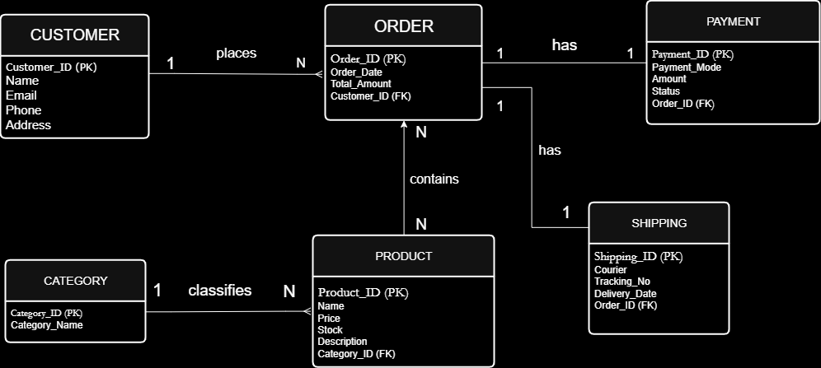

Fig. 3.2: Relational Schema Diagram

3.6 Primary Keys and Foreign Keys
Table 3.5: Primary Key and Foreign Key Definitions
Table | Primary Key | Foreign Key | References (Table.Column)
CUSTOMER | customer_id | — | —
CATEGORY | category_id | — | —
PRODUCT | product_id | category_id | CATEGORY.category_id
ORDER | order_id | customer_id | CUSTOMER.customer_id
ORDER_ITEM | (order_id, product_id) | order_id | ORDER.order_id
ORDER_ITEM | (order_id, product_id) | product_id | PRODUCT.product_id
PAYMENT | payment_id | order_id | ORDER.order_id
SHIPPING | shipping_id | order_id | ORDER.order_id
REVIEW | review_id | customer_id | CUSTOMER.customer_id
REVIEW | review_id | product_id | PRODUCT.product_id
CART | cart_id | customer_id | CUSTOMER.customer_id

3.7 Normalization up to 3NF
Normalization is a database design technique used to organize data efficiently, reduce redundancy, and maintain data integrity. The Online Shopping System database has been normalized up to Third Normal Form (3NF).

First Normal Form (1NF)
A relation is in First Normal Form if all attributes contain atomic values and there are no repeating groups. Initially, customer, product, and order details may be stored in a single table containing multiple product entries for the same order. To achieve 1NF, repeating groups are removed and each attribute is stored as a single value. Separate tables such as CUSTOMER, PRODUCT, ORDERS, and ORDER_ITEM are created to store data in a structured manner.

Second Normal Form (2NF)
A relation is in Second Normal Form if it is already in 1NF and all non-key attributes are fully dependent on the entire primary key. In the Online Shopping System, the ORDER_ITEM table uses a composite primary key consisting of order_id and product_id. Attributes such as quantity and unit_price depend on the complete key rather than only a part of it. Additional entities such as PAYMENT, SHIPPING, REVIEW, and CART are separated into independent tables to eliminate partial dependencies.

Third Normal Form (3NF)
A relation is in Third Normal Form if it is already in 2NF and contains no transitive dependencies. In the proposed database, customer information depends only on customer_id, category information depends only on category_id, payment details depend only on payment_id, and shipping details depend only on shipping_id. By separating these entities into individual tables and linking them through foreign keys, transitive dependencies are eliminated.
UNF → 1NF → 2NF → 3NF
Table 3.6: Normalization Steps
Normal Form | Condition Satisfied | Anomaly Removed | Resulting Tables
UNF | Repeating groups exist | None | ORDER_DETAILS
1NF | Atomic values, no repeating groups | Repeating-group anomaly | CUSTOMER, CATEGORY, PRODUCT, ORDER, ORDER_ITEM
2NF | Full functional dependency on primary key | Partial dependency anomaly | PAYMENT, SHIPPING, REVIEW, CART separated
3NF | No transitive dependencies | Update, insertion, and deletion anomalies | Final normalized schema with 9 tables

CHAPTER 4: DATABASE IMPLEMENTATION
(Deliverables of Review – II)

4.1 Database and Table Creation – DDL
The database was created based on the relational schema and normalized design developed in the previous chapters. All tables were implemented with appropriate primary key, foreign key, unique, not null, check, and default constraints to ensure data integrity and consistency.
-- CREATE DATABASE
CREATE DATABASE OnlineShoppingSystem;
USE OnlineShoppingSystem;

-- CATEGORY TABLE
CREATE TABLE Category (
category_id INT PRIMARY KEY AUTO_INCREMENT,
category_name VARCHAR(100) NOT NULL UNIQUE,
description VARCHAR(255)
);

-- CUSTOMER TABLE
CREATE TABLE Customer (
customer_id INT PRIMARY KEY AUTO_INCREMENT,
name VARCHAR(100) NOT NULL,
email VARCHAR(100) NOT NULL UNIQUE,
phone VARCHAR(15) NOT NULL,
password VARCHAR(100) NOT NULL,
address VARCHAR(255) NOT NULL,
city VARCHAR(50),
pincode VARCHAR(10)
);

-- PRODUCT TABLE
CREATE TABLE Product (
product_id INT PRIMARY KEY AUTO_INCREMENT,
name VARCHAR(100) NOT NULL,
description VARCHAR(255),
price DECIMAL(10,2) NOT NULL CHECK(price > 0),
stock_qty INT NOT NULL DEFAULT 0 CHECK(stock_qty >= 0),
category_id INT NOT NULL,
FOREIGN KEY (category_id)
REFERENCES Category(category_id)
);

-- CART TABLE
CREATE TABLE Cart (
cart_id INT PRIMARY KEY AUTO_INCREMENT,
customer_id INT UNIQUE,
created_date DATE DEFAULT (CURRENT_DATE),
FOREIGN KEY (customer_id)
REFERENCES Customer(customer_id)
);

-- ORDERS TABLE
CREATE TABLE Orders (
order_id INT PRIMARY KEY AUTO_INCREMENT,
order_date DATE DEFAULT (CURRENT_DATE),
total_amount DECIMAL(10,2) DEFAULT 0,
status VARCHAR(30) DEFAULT 'Pending',
customer_id INT NOT NULL,
FOREIGN KEY (customer_id)
REFERENCES Customer(customer_id)
);

-- ORDER_ITEM TABLE
CREATE TABLE Order_Item (
order_id INT,
product_id INT,
quantity INT NOT NULL CHECK(quantity > 0),
unit_price DECIMAL(10,2) NOT NULL CHECK(unit_price > 0),

PRIMARY KEY(order_id, product_id),

FOREIGN KEY(order_id)
REFERENCES Orders(order_id)
ON DELETE CASCADE,

FOREIGN KEY(product_id)
REFERENCES Product(product_id)
ON DELETE RESTRICT
);

-- PAYMENT TABLE
CREATE TABLE Payment (
payment_id INT PRIMARY KEY AUTO_INCREMENT,
order_id INT UNIQUE,
payment_mode VARCHAR(30) NOT NULL,
amount DECIMAL(10,2) NOT NULL CHECK(amount > 0),
pay_date DATE,
status VARCHAR(20) DEFAULT 'Pending',

FOREIGN KEY(order_id)
REFERENCES Orders(order_id)
);

-- SHIPPING TABLE
CREATE TABLE Shipping (
shipping_id INT PRIMARY KEY AUTO_INCREMENT,
order_id INT UNIQUE,
address VARCHAR(255) NOT NULL,
courier VARCHAR(100),
tracking_no VARCHAR(100) UNIQUE,
delivery_date DATE,

FOREIGN KEY(order_id)
REFERENCES Orders(order_id)
);

-- REVIEW TABLE
CREATE TABLE Review (
review_id INT PRIMARY KEY AUTO_INCREMENT,
customer_id INT NOT NULL,
product_id INT NOT NULL,
rating INT CHECK(rating BETWEEN 1 AND 5),
comment VARCHAR(255),
review_date DATE DEFAULT (CURRENT_DATE),

FOREIGN KEY(customer_id)
REFERENCES Customer(customer_id),

FOREIGN KEY(product_id)
REFERENCES Product(product_id)
);

-- ALTER TABLE EXAMPLE
ALTER TABLE Product
ADD COLUMN brand VARCHAR(50);

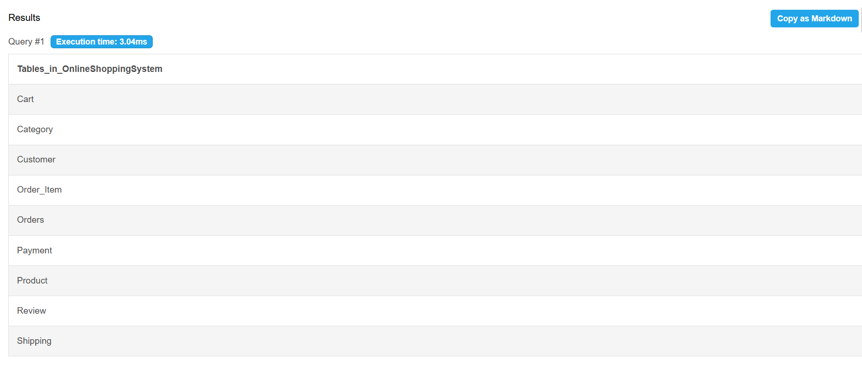

Fig. 4.1: Successful Creation of Tables

4.2 Sample Data Insertion – DML
Table 4.1: Sample Data Summary
S.No | Table Name | No. of Records Inserted | Screenshot Reference
1 | CATEGORY | 5 | Fig. 4.2(a)
2 | CUSTOMER | 10 | Fig. 4.2(b)
3 | PRODUCT | 15 | Fig. 4.2(c)
4 | CART | 10 | Fig. 4.2(d)
5 | ORDERS | 12 | Fig. 4.2(e)
6 | ORDER_ITEM | 25 | Fig. 4.2(f)
7 | PAYMENT | 12 | Fig. 4.2(g)
8 | SHIPPING | 12 | Fig. 4.2(h)
9 | REVIEW | 20 | Fig. 4.2(i)

-- CATEGORY
INSERT INTO Category(category_name, description)
VALUES
('Electronics','Electronic Devices'),
('Fashion','Clothing and Accessories'),
('Books','Educational and Story Books'),
('Home Appliances','Home Utility Products'),
('Sports','Sports Equipment');

-- CUSTOMER
INSERT INTO Customer
(name,email,phone,password,address,city,pincode)
VALUES
('Rahul Kumar','rahul@gmail.com','9876543210','rahul123',
'Hyderabad','Hyderabad','500001'),

('Priya Sharma','priya@gmail.com','9876543211','priya123',
'Vijayawada','Vijayawada','520001'),

('Anil Kumar','anil@gmail.com','9876543212','anil123',
'Visakhapatnam','Vizag','530001');

-- PRODUCT
INSERT INTO Product
(name,description,price,stock_qty,category_id,brand)
VALUES
('Laptop','Dell Inspiron',55000,20,1,'Dell'),
('Smartphone','Samsung Galaxy',25000,50,1,'Samsung'),
('T-Shirt','Cotton T-Shirt',799,100,2,'Puma'),
('Database Concepts','DBMS Textbook',650,40,3,'McGraw Hill');

-- CART
INSERT INTO Cart(customer_id)
VALUES (1),(2),(3);

-- ORDERS
INSERT INTO Orders
(total_amount,status,customer_id)
VALUES
(55799,'Confirmed',1),
(25000,'Delivered',2),
(650,'Pending',3);

-- ORDER_ITEM
INSERT INTO Order_Item
(order_id,product_id,quantity,unit_price)
VALUES
(1,1,1,55000),
(1,3,1,799),
(2,2,1,25000),
(3,4,1,650);

-- PAYMENT
INSERT INTO Payment
(order_id,payment_mode,amount,pay_date,status)
VALUES
(1,'UPI',55799,'2025-09-01','Completed'),
(2,'Credit Card',25000,'2025-09-02','Completed'),
(3,'Cash on Delivery',650,'2025-09-03','Pending');

-- SHIPPING
INSERT INTO Shipping
(order_id,address,courier,tracking_no,delivery_date)
VALUES
(1,'Hyderabad','BlueDart','TRK1001','2025-09-05'),
(2,'Vijayawada','DTDC','TRK1002','2025-09-06'),
(3,'Visakhapatnam','Delhivery','TRK1003','2025-09-08');

-- REVIEW
INSERT INTO Review
(customer_id,product_id,rating,comment)
VALUES
(1,1,5,'Excellent Laptop'),
(2,2,4,'Good Performance'),
(3,4,5,'Very Useful Book');

Fig. 4.2(a): Sample Data Inserted into Category Table
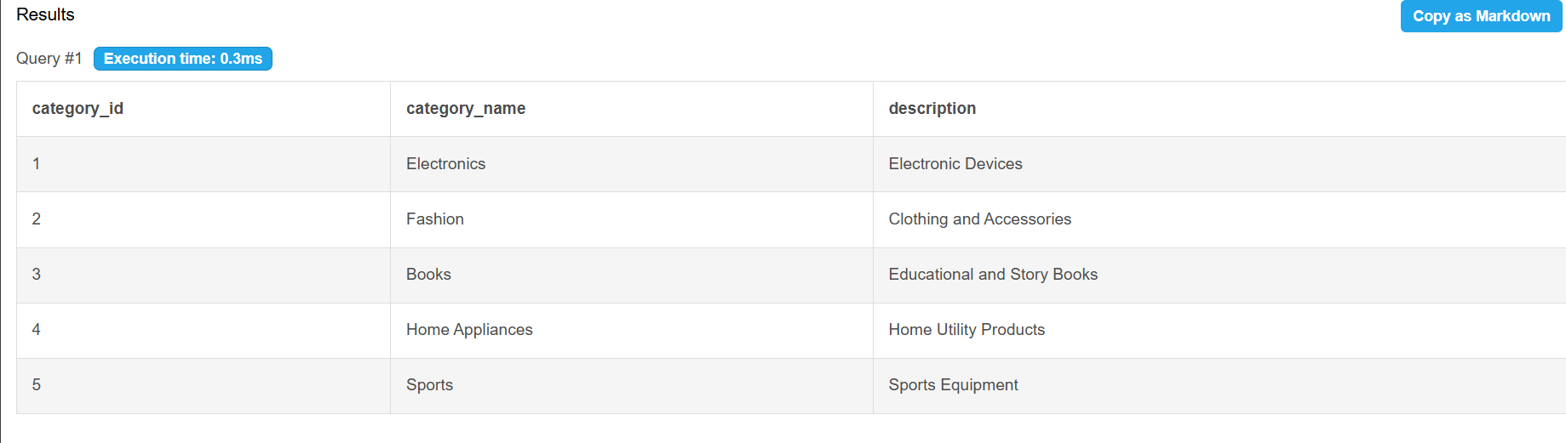
Fig. 4.2(b): Sample Data Inserted into Customer Table
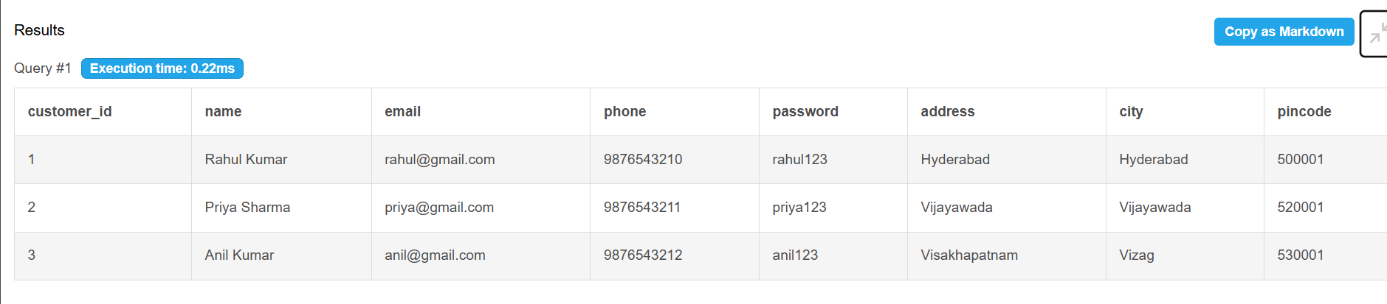
Fig. 4.2(c): Sample Data Inserted into Product Table
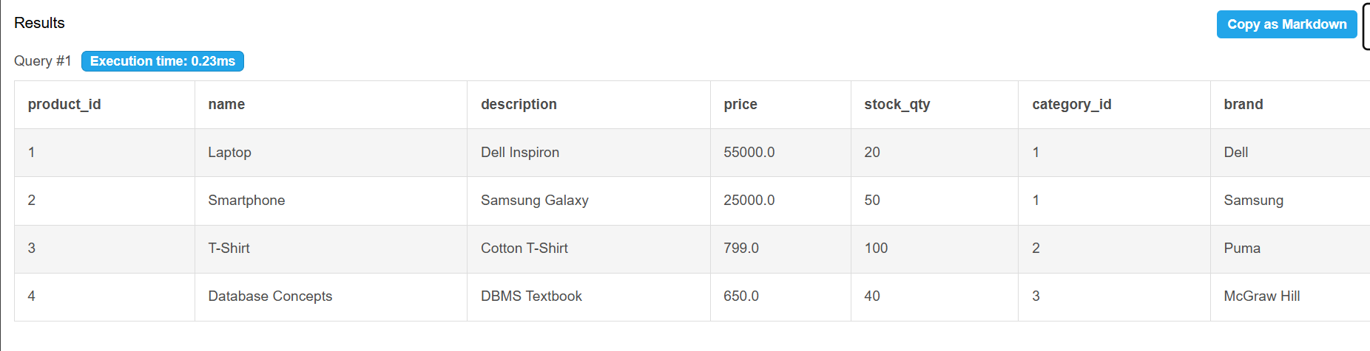
Fig. 4.2(d): Sample Data Inserted into Cart Table
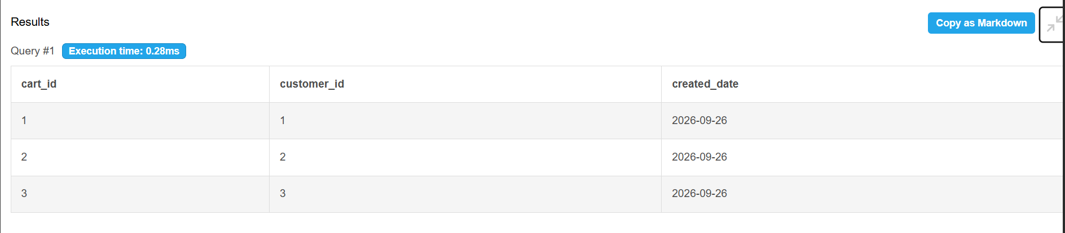
Fig. 4.2(e): Sample Data Inserted into Orders Table
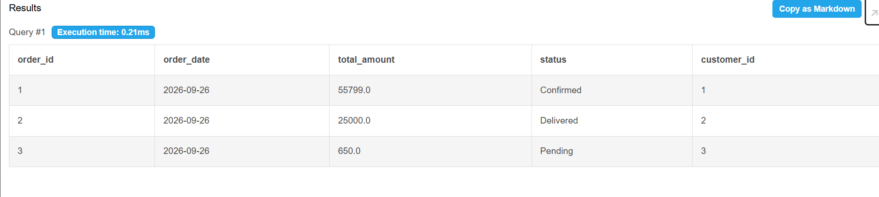
Fig. 4.2(f): Sample Data Inserted into Order_Item Table
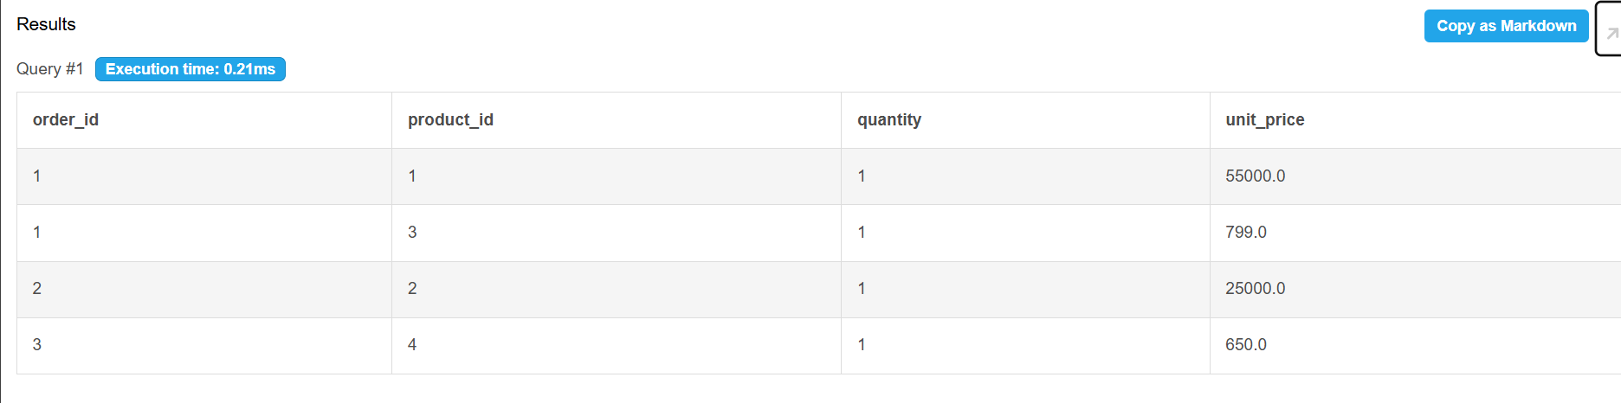

Fig. 4.2(g): Sample Data Inserted into Payment Table
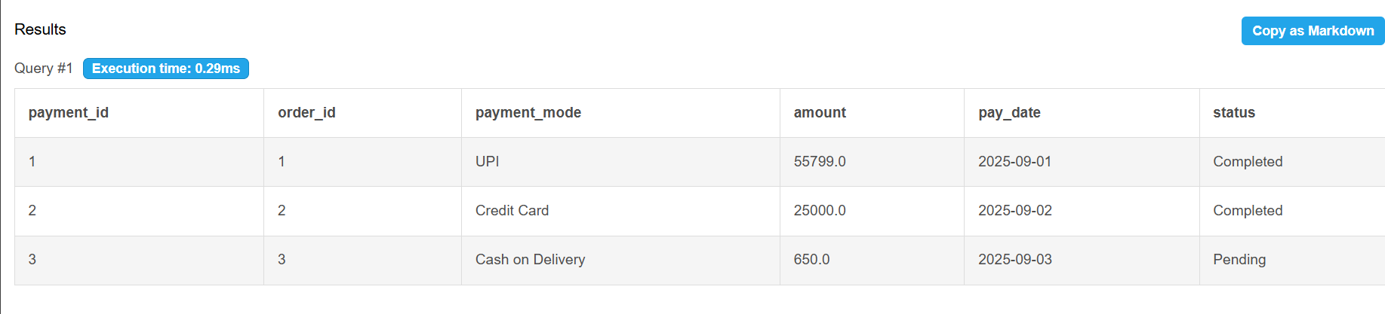

Fig. 4.2(h): Sample Data Inserted into Shipping Table
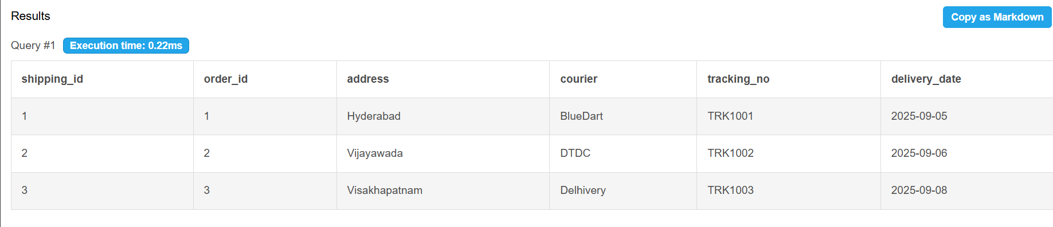

Fig. 4.2(i): Sample Data Inserted into Review Table
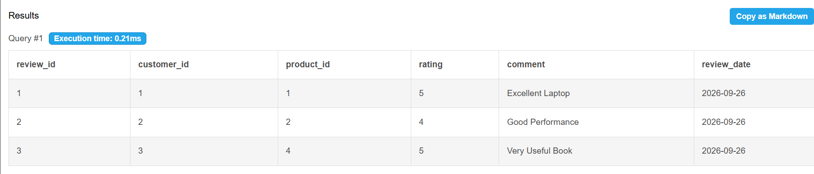

Fig. 4.2: Sample Data Inserted into the Tables

4.3 Constraints and Data Integrity
Table 4.2: Constraints and Data Integrity Rules
Constraint / Validation | Applied On (Table.Column) | Purpose
PRIMARY KEY | CUSTOMER.customer_id | Ensures each customer has a unique identifier
PRIMARY KEY | PRODUCT.product_id | Prevents duplicate product records
PRIMARY KEY (Composite) | ORDER_ITEM(order_id, product_id) | Prevents duplicate product entries in the same order
FOREIGN KEY | PRODUCT.category_id | Ensures every product belongs to a valid category
FOREIGN KEY | ORDERS.customer_id | Ensures every order is linked to an existing customer
FOREIGN KEY | PAYMENT.order_id | Ensures payment records exist only for valid orders
FOREIGN KEY | SHIPPING.order_id | Ensures shipping details correspond to valid orders
FOREIGN KEY | REVIEW.customer_id | Allows reviews only from registered customers
FOREIGN KEY | REVIEW.product_id | Allows reviews only for existing products
NOT NULL | CUSTOMER.name | Prevents empty customer names
NOT NULL | CUSTOMER.email | Ensures email information is mandatory
UNIQUE | CUSTOMER.email | Prevents duplicate customer accounts
UNIQUE | CATEGORY.category_name | Prevents duplicate category names
CHECK(price > 0) | PRODUCT.price | Prevents invalid product prices
CHECK(stock_qty >= 0) | PRODUCT.stock_qty | Prevents negative inventory values
CHECK(quantity > 0) | ORDER_ITEM.quantity | Ensures valid order quantities
CHECK(rating BETWEEN 1 AND 5) | REVIEW.rating | Restricts ratings to 1–5 stars
DEFAULT 'Pending' | ORDERS.status | Assigns default order status
DEFAULT CURRENT_DATE | ORDERS.order_date | Automatically stores order date
ON DELETE CASCADE | ORDER_ITEM.order_id | Deletes order items when an order is removed
ON DELETE RESTRICT | ORDER_ITEM.product_id | Prevents deletion of products referenced in orders

4.4 Data Validation Rules
To confirm that the constraints actually work, three invalid statements were executed deliberately. In each case, the database rejected the statement and no row was inserted or updated.
(a) Referential Integrity — an order for a customer who does not exist:
INSERT INTO Orders
(order_id, order_date, total_amount, status, customer_id)
VALUES
(101, '2025-09-15', 5000, 'Pending', 999);
ERROR 1452 (23000): Cannot add or update a child row: a foreign key constraint fails
(OnlineShoppingSystem.Orders , CONSTRAINT orders_ibfk_1,FOREIGN KEY (customer_id)
REFERENCES Customer(customer_id))

(b) CHECK Constraint — a product with a negative price:
INSERT INTO Product
(product_id, name, description, price, stock_qty, category_id)
VALUES
(20, 'Test Product', 'Invalid Product', -500, 10, 1);
ERROR 3819 (HY000): Check constraint 'product_chk_1' is violated.
(c) UNIQUE Constraint — duplicate customer email:
INSERT INTO Customer
(name, email, phone, password, address, city, pincode)
VALUES
('Test User', 'rahul@gmail.com', '9876543299', 'test123', 'Hyderabad', 'Hyderabad', '500001');
ERROR 1062 (23000): Duplicate entry 'rahul@gmail.com' for key 'Customer.email'.

Fig. 4.3: Referential Integrity Enforced by the Database

CHAPTER 5: SQL OPERATIONS AND QUERIES

5.1 DQL – Basic Retrieval Queries

Q1. Display all customer details
SQL:
SELECT * FROM Customer;
OUTPUT:
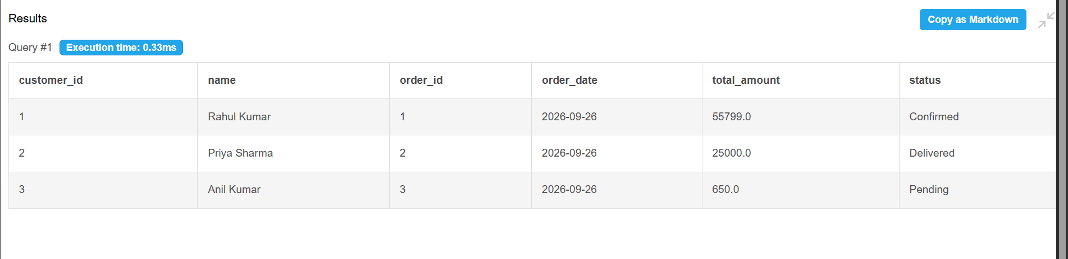

Q2. Display products whose price is greater than 10,000
SQL:
SELECT * FROM Product
WHERE price > 10000;

OUTPUT:
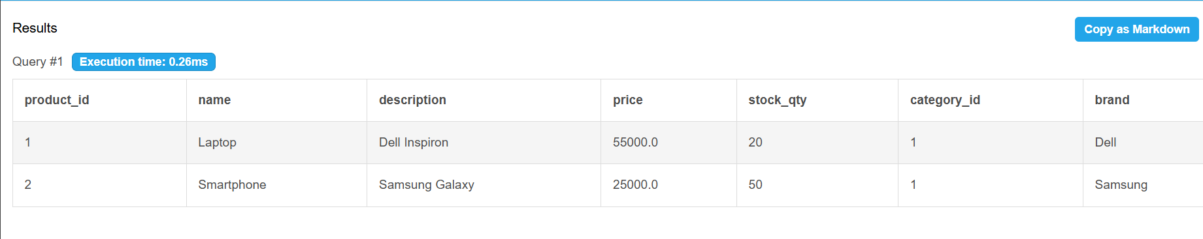

Q3. Display only delievered orders
SQL:
SELECT * FROM Orders
WHERE status='Delivered';

OUTPUT: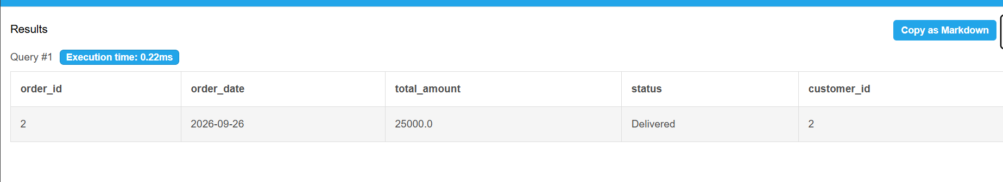

Table 5.1: Basic Retrieval Queries

5.2 Join Operations
Q4. Natural join
SQL:
SELECT customer_id, name, order_id, order_date, total_amount
FROM Customer NATURAL JOIN Orders;

OUTPUT: 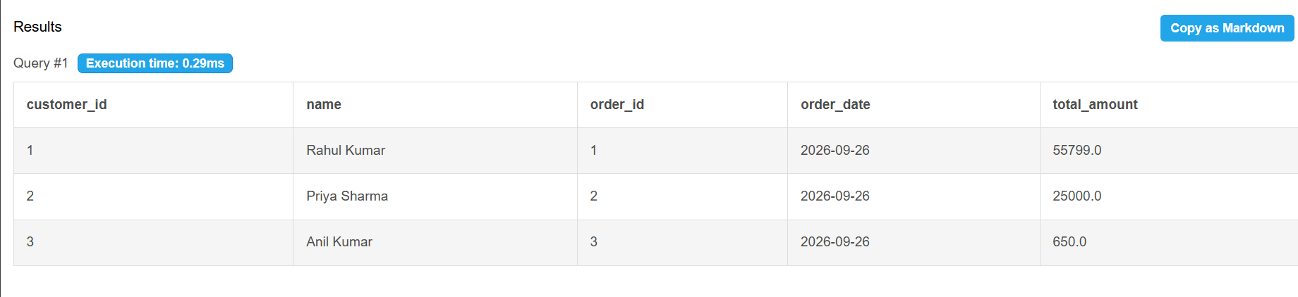

Q5. Inner join
SQL:
SELECT C.name, O.order_id, O.total_amount
FROM Customer C
INNER JOIN Orders O
ON C.customer_id = O.customer_id;

OUTPUT:
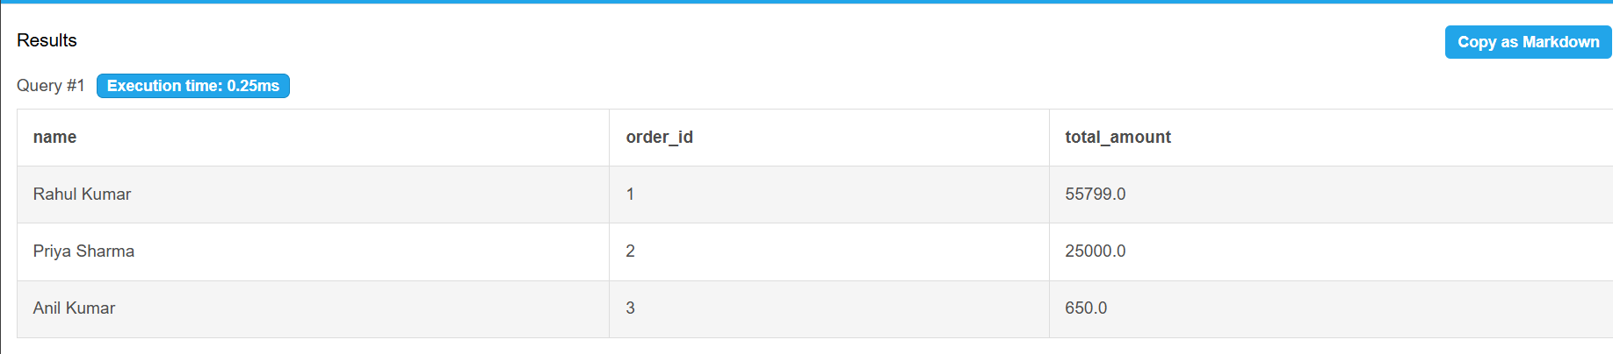

Q6. Left outer join
SQL:
SELECT C.customer_id, C.name, O.order_id
FROM Customer C
LEFT OUTER JOIN Orders O
ON C.customer_id = O.customer_id

OUTPUT:
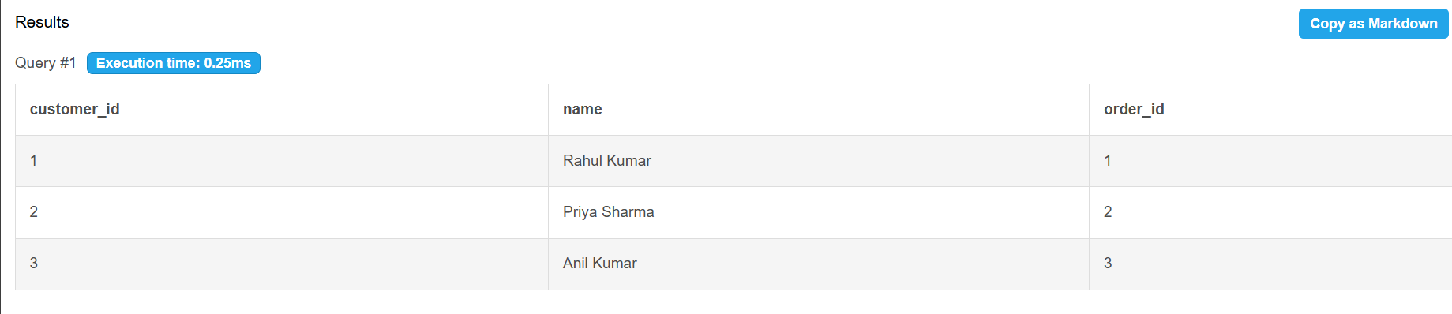

Q7. Right outer join
SQL:
SELECT C.name, O.order_id, O.status
FROM Customer C
RIGHT OUTER JOIN Orders O
ON C.customer_id = O.customer_id;

OUTPUT:
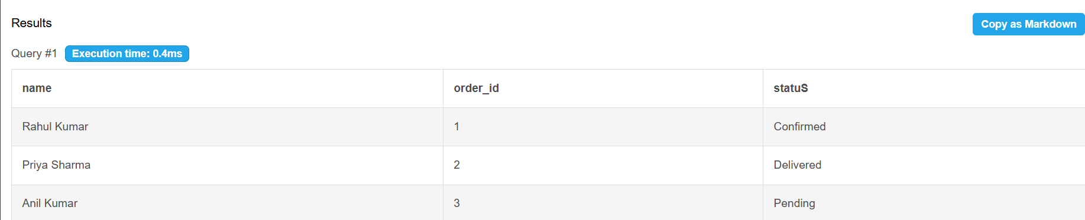

5.3 Aggregate Functions, GROUP BY and HAVING

Q8. SUM() –Calculates total revenue generated from all orders
SQL:
SELECT SUM(total_amount) AS Total_Sales
FROM Orders;

OUTPUT:
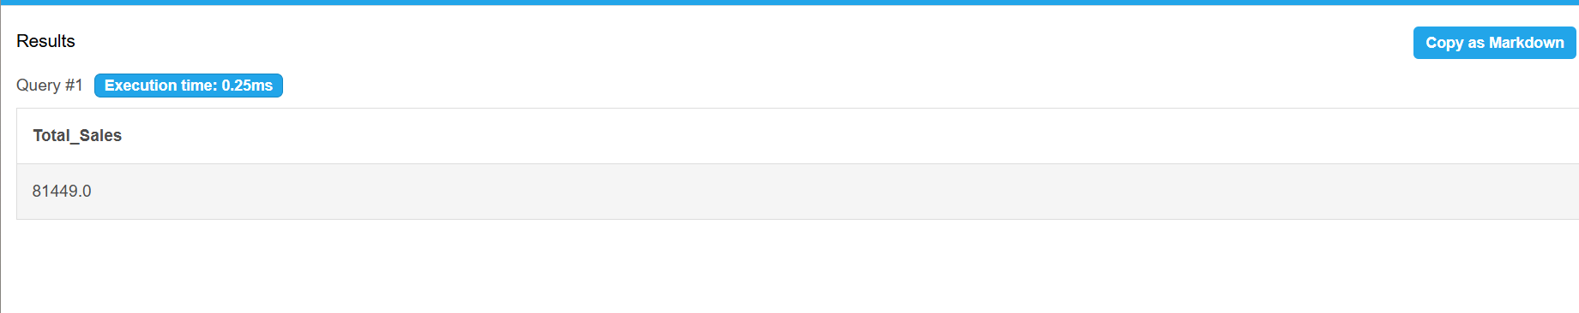

Q9. GROUP BY—Shows how many orders each customer has placed
SQL:
SELECT customer_id,
COUNT(order_id) AS Total_Orders
FROM Orders
GROUP BY customer_id;

OUTPUT:
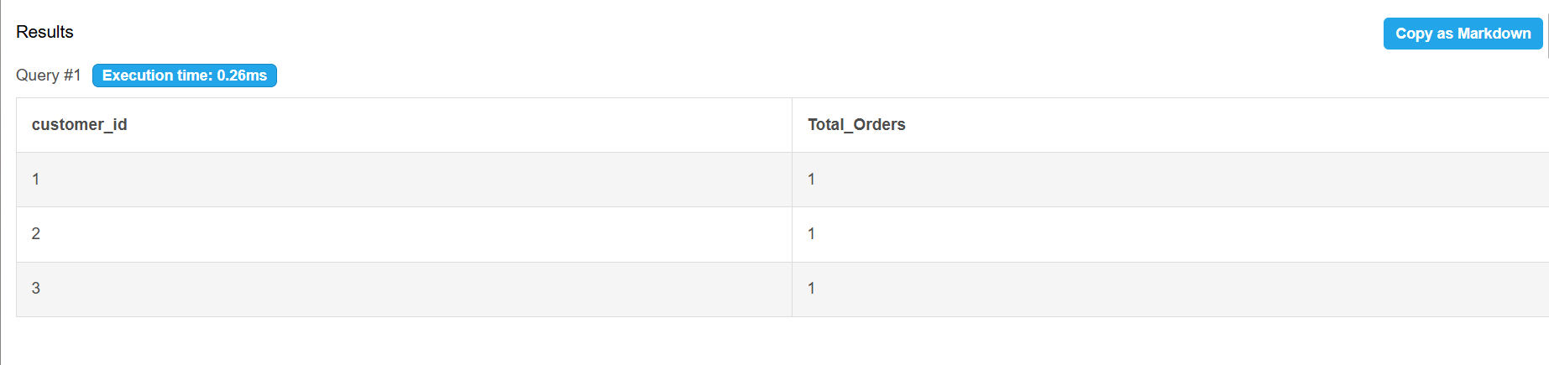

Q10. GROUP BY with HAVING—Displays categories containing more than one product
SQL:
SELECT category_id,
COUNT(product_id) AS Total_Products
FROM Product
GROUP BY category_id
HAVING COUNT(product_id) > 1;

OUTPUT:
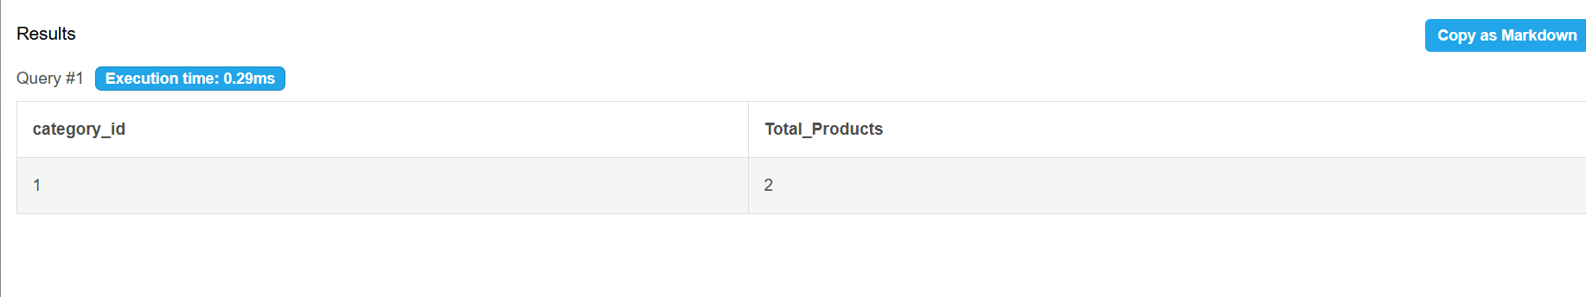

Q10. GROUP BY with HAVING
SQL:
SELECT customer_id,
COUNT(order_id) AS Total_Orders
FROM Orders
GROUP BY customer_id
HAVING COUNT(order_id) > 1;

OUTPUT:
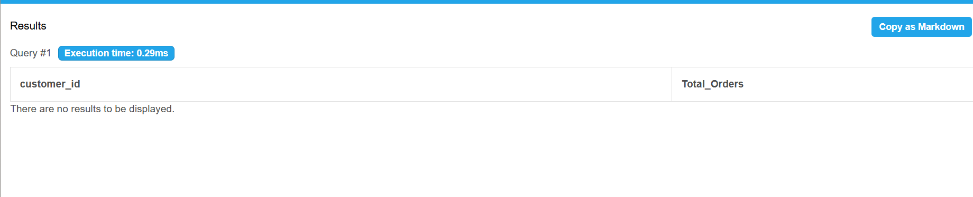

5.4 Nested and Correlated Subqueries
Q11. Nested Subquery—Products whose price is above the average product price
SQL:
SELECT *
FROM Product
WHERE price >
(
SELECT AVG(price)
FROM Product
);
OUTPUT:
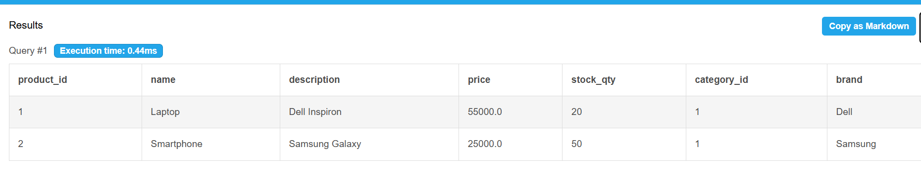

Q12. Nested Subquery—Displays customers who have placed at least one order
SQL:
SELECT *
FROM Customer
WHERE customer_id IN
(
SELECT customer_id
FROM Orders
);
OUTPUT:
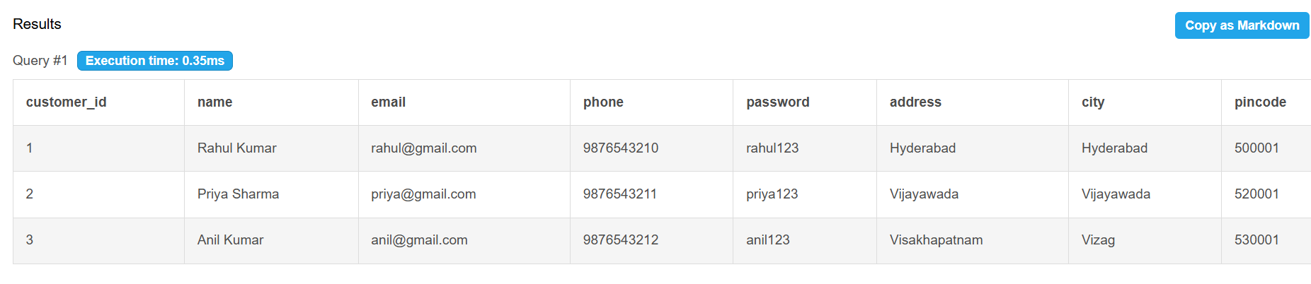

Q13. Correlated Sub query –Order amount is greater than their own average order value
SQL:
SELECT DISTINCT C.customer_id,
C.name
FROM Customer C
JOIN Orders O
ON C.customer_id = O.customer_id
WHERE O.total_amount >
(
SELECT AVG(O2.total_amount)
FROM Orders O2
WHERE O2.customer_id = O.customer_id
);
OUTPUT:
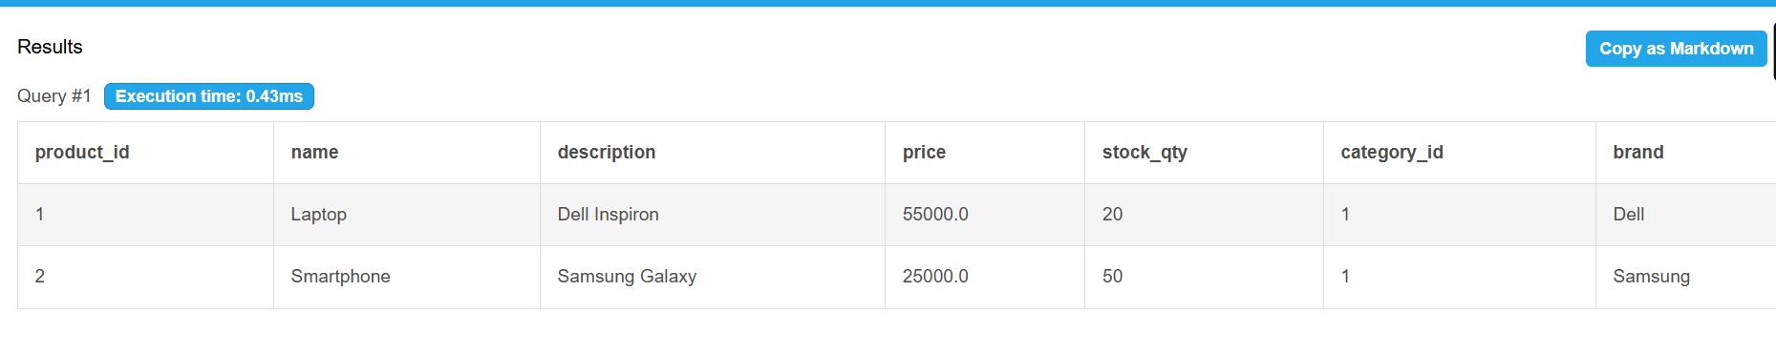

Q14. Correlated Subquery—Displays products whose price is greater than average price
SQL:
SELECT P1.product_id,
P1.name,
P1.price
FROM Product P1
WHERE P1.price >
(
SELECT AVG(P2.price)
FROM Product P2
WHERE P2.category_id = P1.category_id
);

OUTPUT:
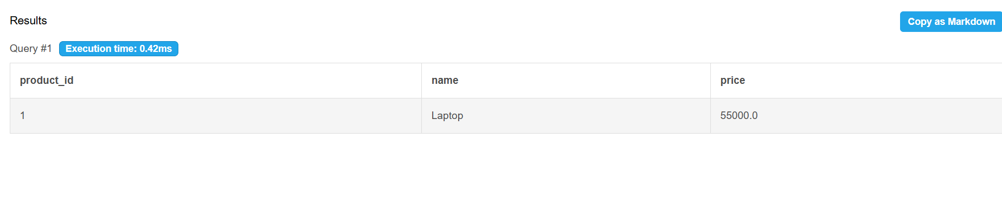

5.5 Views and Relational Set Operations

Q15. UNION—Returns unique customer IDs appearing in either table
SQL:
SELECT customer_id
FROM Customer

UNION

SELECT customer_id
FROM Orders
OUTPUT:
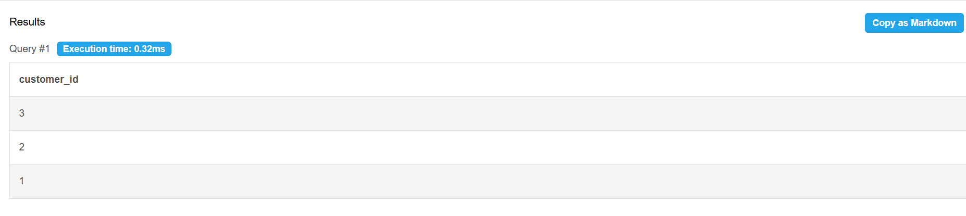

Q16. UNION ALL—Returns all customer ids including duplicate values
SQL:
SELECT customer_id
FROM Customer

UNION ALL

SELECT customer_id
FROM Orders;
OUTPUT:
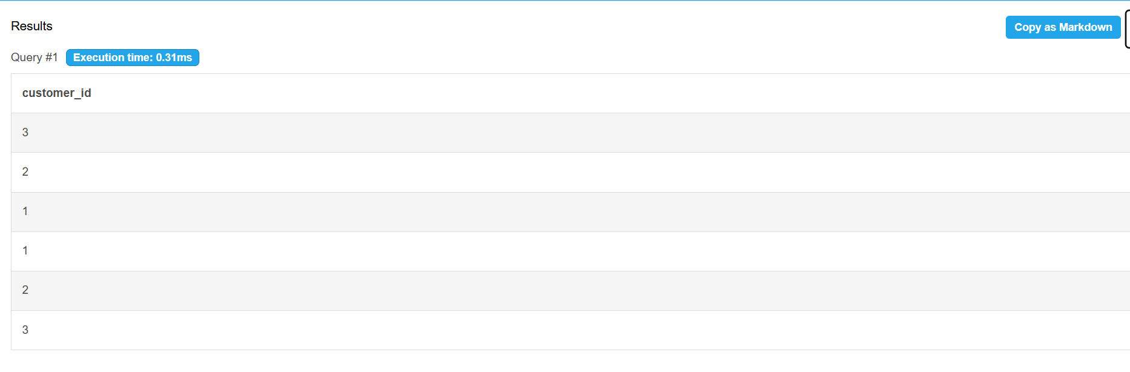

Q17. INTERSECT Equivalent—Displays customers who have placed orders
SQL:
SELECT customer_id
FROM Customer
WHERE customer_id IN
(
SELECT customer_id
FROM Orders
);
OUTPUT:
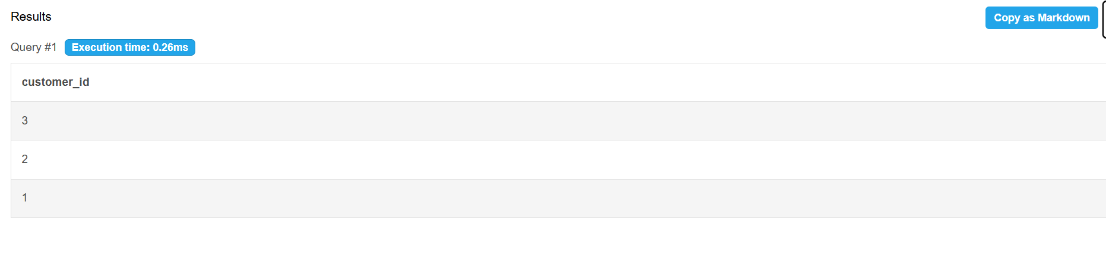

5.6 DCL and TCL Operations
Data Control Language commands were used to create a read-only user for the examination section, and Transaction Control Language commands were used to demonstrate that a partially completed update can be reversed.

(a) DCL—GRANT and REVOKE
GRANT SELECT, INSERT, UPDATE
ON Product
TO user1;
REVOKE UPDATE
ON Product
FROM user1;

(b)TCL—COMMIT ,ROLLBACK AND SAVEPOINT
INSERT INTO Product(product_id, name, price, stock)
VALUES (101, 'Laptop', 50000, 20);

COMMIT;
DELETE FROM Product
WHERE product_id = 101;

ROLLBACK;
SAVEPOINT sp1;

UPDATE Product
SET price = 55000
WHERE product_id = 101;
ROLLBACK TO sp1;

CHAPTER 6: MODULES AND FUNCTIONALITIES
Table 6.1: Modules and Their Functionalities
S.No | Module Name | Functionality | Tables Involved
1 | Customer Management Module | Manages customer registration, login, profile information, addresses, and account details. | CUSTOMER
2 | Category Management Module | Stores and manages product categories such as Electronics, Fashion, Books, etc. | CATEGORY
3 | Product Management Module | Handles product information including product name, description, price, stock quantity, and category assignment | PRODUCT, CATEGORY
4 | Shopping Cart Module | Allows customers to add, view, update, and remove products before placing an order. | CART, PRODUCT, CUSTOMER
5 | Order Management Module | Processes customer orders, maintains order details, order status, and order history. | ORDERS, ORDER_ITEM, CUSTOMER
6 | Payment Management Module | Records payment transactions, payment methods, payment status, and payment dates. | PAYMENT, ORDERS
7 | Shipping Management Module | Stores shipping details, courier information, tracking numbers, and delivery dates. | SHIPPING, ORDERS
8 | Review and Rating Module | Allows customers to submit ratings and reviews for purchased products. | REVIEW, CUSTOMER, PRODUCT
8 | Inventory Management Module | Maintains available stock quantities and updates inventory after purchases. | PRODUCT, ORDER_ITEM
9 | Reporting and Query Module | Generates reports such as customer orders, sales details, product information, payment summaries, and shipping reports using SQL queries. | CUSTOMER, PRODUCT, ORDERS, PAYMENT, SHIPPING, REVIEW

The Online Shopping System is centered around the Order Management module, which connects customers, products, payments, and shipping information through foreign key relationships. The ORDER_ITEM table resolves the many-to-many relationship between orders and products, while the integrated design ensures data integrity, reduces redundancy, and supports efficient transaction processing across the database

CHAPTER 7: RESULTS – SAMPLE OUTPUTS AND SCREENSHOTS
Report 1: Customer order report

SELECT C.customer_id,
C.name,
O.order_id,
O.order_date,
O.total_amount,
O.status
FROM Customer C
JOIN Orders O
ON C.customer_id = O.customer_id;

Fig. 7.1: Shows customer order history
Report 2: product inventory report
SELECT product_id,
name,
price,
stock_qty
FROM Product
ORDER BY stock_qty ASC
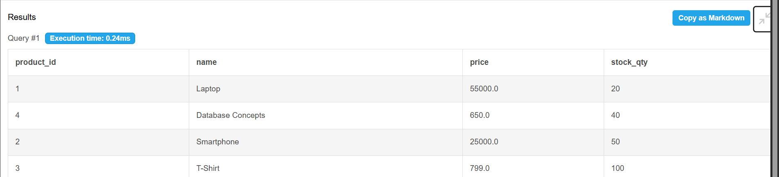

Fig. 7.2: Product inventory report
Report 3: Sales summary report
SELECT COUNT(order_id) AS Total_Orders,
SUM(total_amount) AS Total_Sales,
AVG(total_amount) AS Average_Order_Value
FROM Orders;
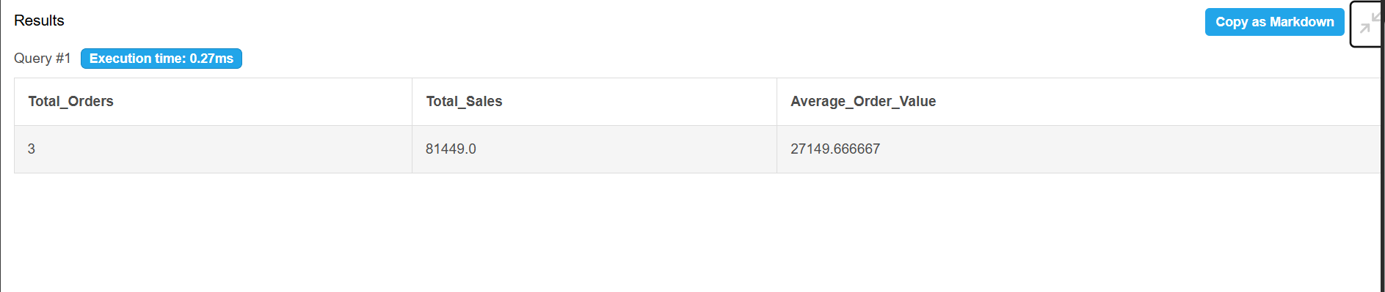

Fig. 7.3: Sales summary report
REPORT 4: Payment and shipping report
SELECT O.order_id,
C.name,
P.payment_mode,
P.status AS Payment_Status,
S.courier,
S.tracking_no
FROM Orders O
JOIN Customer C
ON O.customer_id = C.customer_id
JOIN Payment P
ON O.order_id = P.order_id
JOIN Shipping S
ON O.order_id = S.order_id;

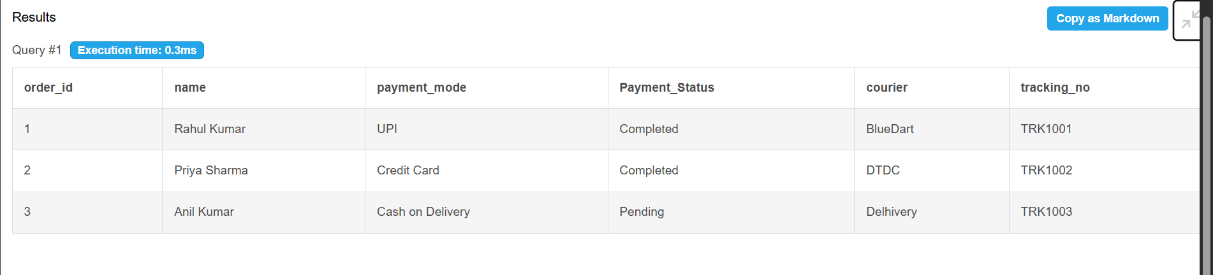

Fig. 7.4: payment and shipping report

CHAPTER 8: TESTING AND DATA VALIDATION
The database was tested using both valid and invalid inputs to verify the correctness of constraints, relationships, and SQL operations. All test cases produced the expected results, confirming that the Online Shopping System maintains data integrity and functions correctly.
Table 8.1: Test Cases and Results
TC No. | Test Case Description | Input / Action | Expected Result | Actual Result | Status
TC01 | Insert a valid customer record | Valid customer details | Record inserted successfully | Record inserted | Pass
TC02 | Insert customer with duplicate email | Existing email address | Database rejects insertion | Error generated | Pass
TC03 | Insert product with negative price | Price = -500 | CHECK constraint violation | Error generated | Pass
TC04 | Insert order with invalid customer ID | customer_id = 999 | Foreign key violation | Error generated | Pass
TC05 | Insert review with rating > 5 | Rating = 7 | CHECK constraint violation | Error generated | Pass
TC06 | Retrieve customer order details | Execute JOIN query | Correct records displayed | Correct output displayed | Pass
TC07 | Generate sales summary report | Execute aggregate query | Total sales displayed | Correct output displayed | Pass
TC08 | Delete order record | Delete valid order | Order removed successfully | Order removed | Pass

CHAPTER 9: GITHUB REPOSITORY AND TEAM CONTRIBUTION

9.1 Repository Details
GitHub Repository Link: https://github.com/panganikilsaikumarreddy2507-sketch/online-shopping-system
The final SQL script and all project files must be pushed to the team repository.

9.2 Team Responsibilities and Contribution
Table 9.1: Team Responsibilities
S.No | Student Name | Roll Number | Role / Responsibility | Modules Contributed
1. | P.Nikhil sai kumar reddy | 25B11AI895
2. | P.Srilekha thara | 25B11AI966
3. | A.Shanmukha priya lakshmi | 25B11AI056
4. | P.Surya prakash | 25B11AI929

9.3 Review-wise Progress
Table 9.2: Review-wise Progress Record
Review | Date | Deliverables Presented | Remarks of the Guide

CHAPTER 10: CONCLUSION AND FUTURE ENHANCEMENTS

10.1 Conclusion
The Online Shopping System database was successfully designed and implemented using MySQL to manage customers, products, categories, shopping carts, orders, payments, shipping details, and reviews. The database was normalized up to Third Normal Form (3NF) to reduce redundancy and improve data consistency. Various SQL operations such as DDL, DML, DQL, joins, aggregate functions, subqueries, views, and reports were successfully executed. The implementation of primary keys, foreign keys, and validation constraints ensured data integrity, reliability, and efficient data management. The project demonstrates the practical application of database management concepts in developing a structured and scalable e-commerce database system.

10.2 Limitations of the Present Work
Although the database successfully manages online shopping operations, it has certain limitations. The project focuses only on the database layer and does not include a web or mobile user interface. Real-time payment gateway integration, advanced security features, and automated inventory tracking are not implemented. The system also uses sample data and does not address large-scale performance optimization or concurrent user access that may occur in real-world e-commerce applications.

10.3 Future Enhancements
The Online Shopping System can be enhanced by integrating a web-based or mobile application interface for customer interaction. Additional features such as inventory management, order tracking, product recommendation systems, discount and coupon management, and customer support modules can be added. Integration with online payment gateways, advanced authentication mechanisms, and data analytics tools can further improve functionality, security, and user experience. These enhancements would make the system more suitable for deployment in real-world e-commerce environments.

REFERENCES
List textbooks, reference books, documentation and websites referred to. Follow the format shown below.
- Abraham Silberschatz, Henry F. Korth and S. Sudarshan, “Database System Concepts”, 8th Edition, McGraw-Hill, ISBN: 978-1260230508.
- Raghurama Krishnan and Johannes Gehrke, “Database Management Systems”, 4th Edition, McGraw-Hill, ISBN: 978-1260091195.
- Ramez Elmasri and Shamkant B. Navathe, “Fundamentals of Database Systems”, 7th Edition, Pearson, ISBN: 978-0137504277.
- ____________________________________________________________
- ____________________________________________________________

